HOW TO REGISTER AS VOLUNTEER

Go to the menu Register as Volunteer
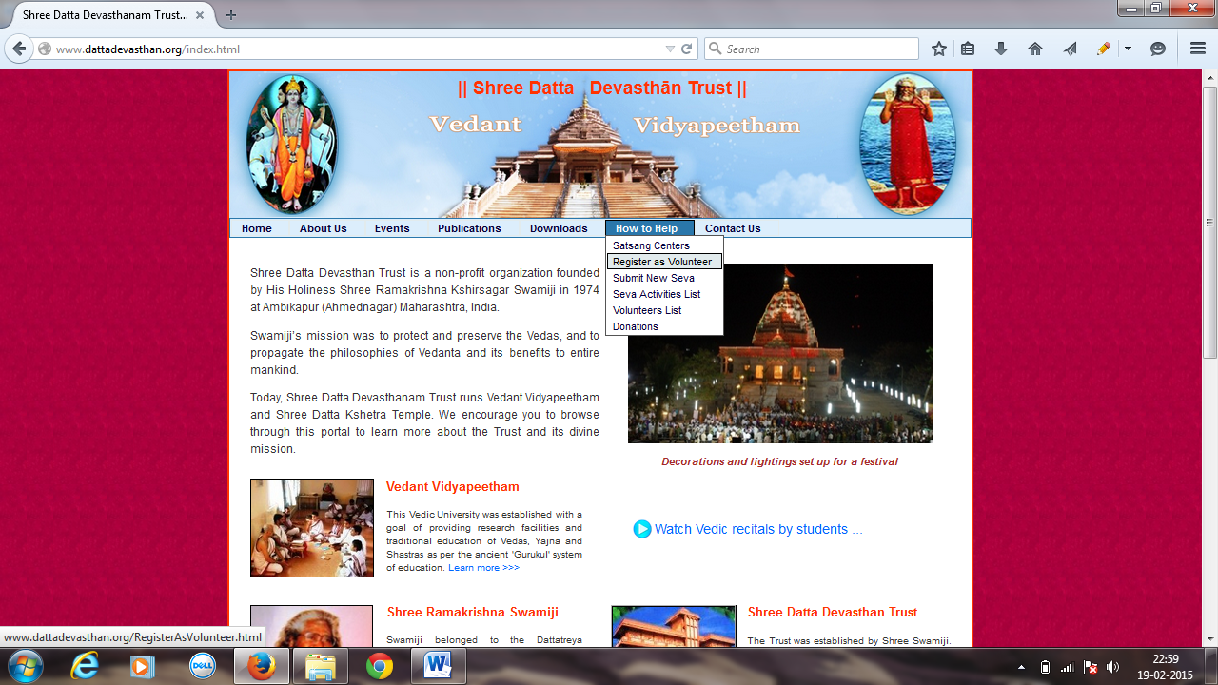

Fill up the form as given below and click on Submit. By doing so you will receive notification anytime a new seva is posted online. Check your spam / junk folder regularly to check the emails. If you are receiving emails in the spam / junk folder, add the email address from which you have received the email to your address book. Once you do that, you will start receiving the emails in your main inbox instead of spam / junk folder

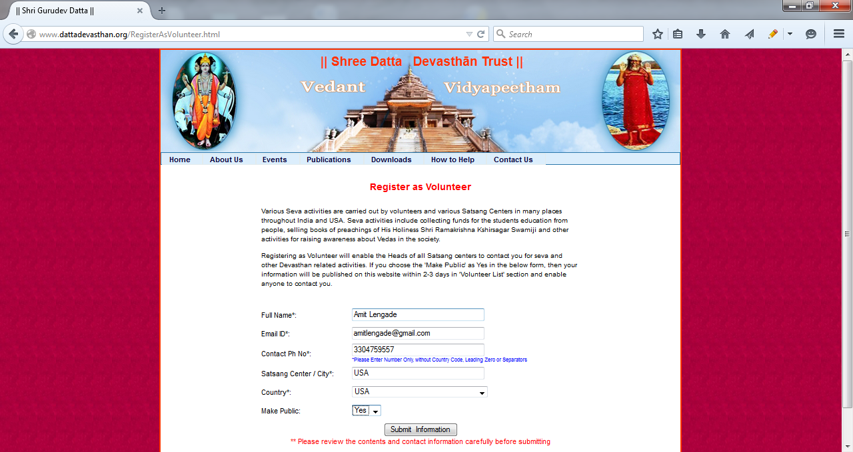

After submitting you will see the following screen
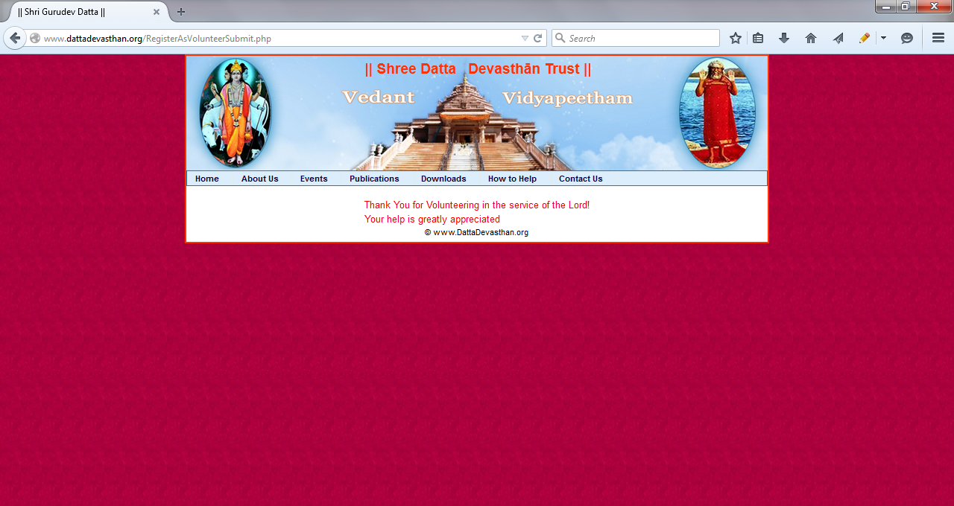
After 2-3 days you can view your name in the Volunteer list as given below
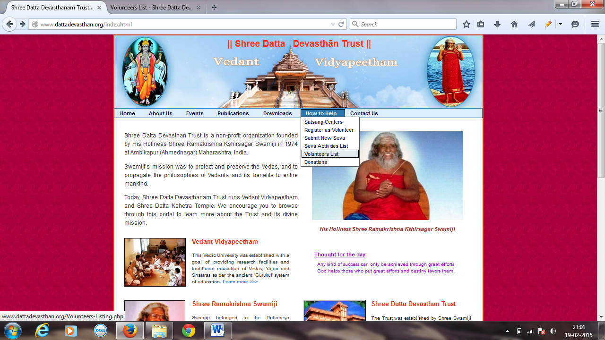

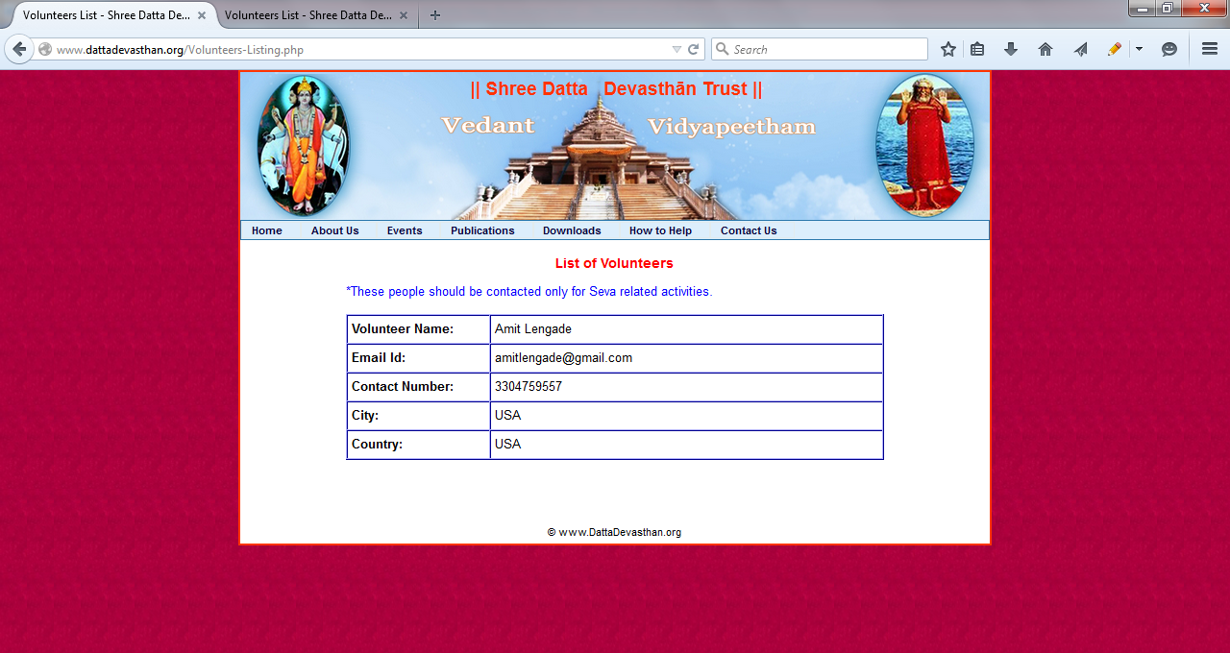

HOW TO SUBMIT NEW SEVA FOR PUBLISHING
Publishing seva on the website will achieve two objectives
- The seva information will be visible on the website to all devotees and they will be able to contact you if they wish to participate
- It will send out email notifications to all registered devotees so they can join the seva if they wish
Go to the menu item as shown below
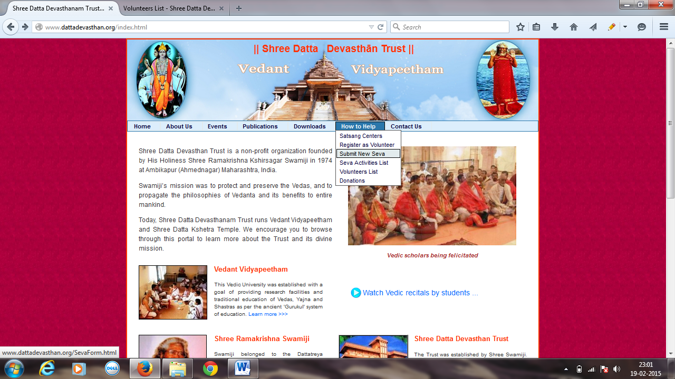

Fill up the Seva form as similar to what is given below and Click on Submit Button. The seva will be reviewed by the Web Administrator team and published on the website within 2-3 days.
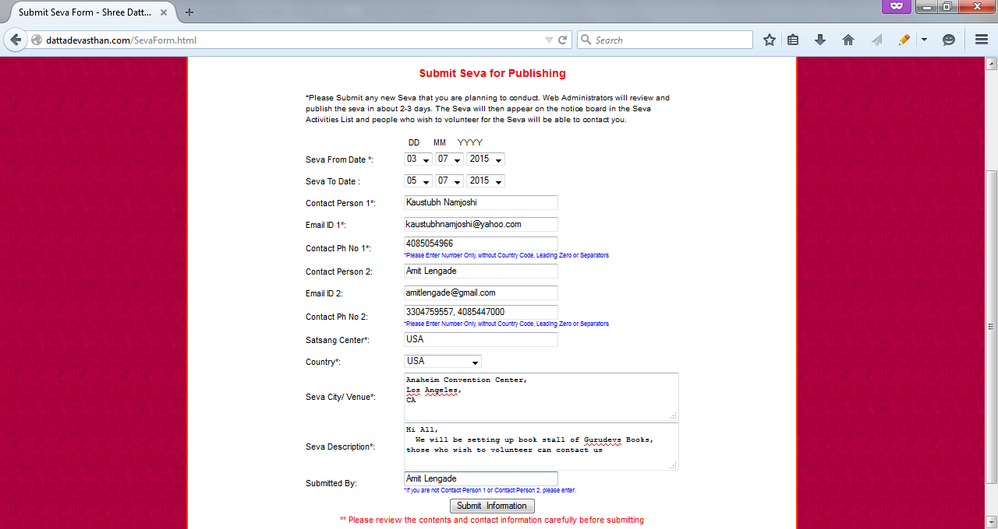

You should then see the following screen with you Event Id Number (e.g. 1 in this case).

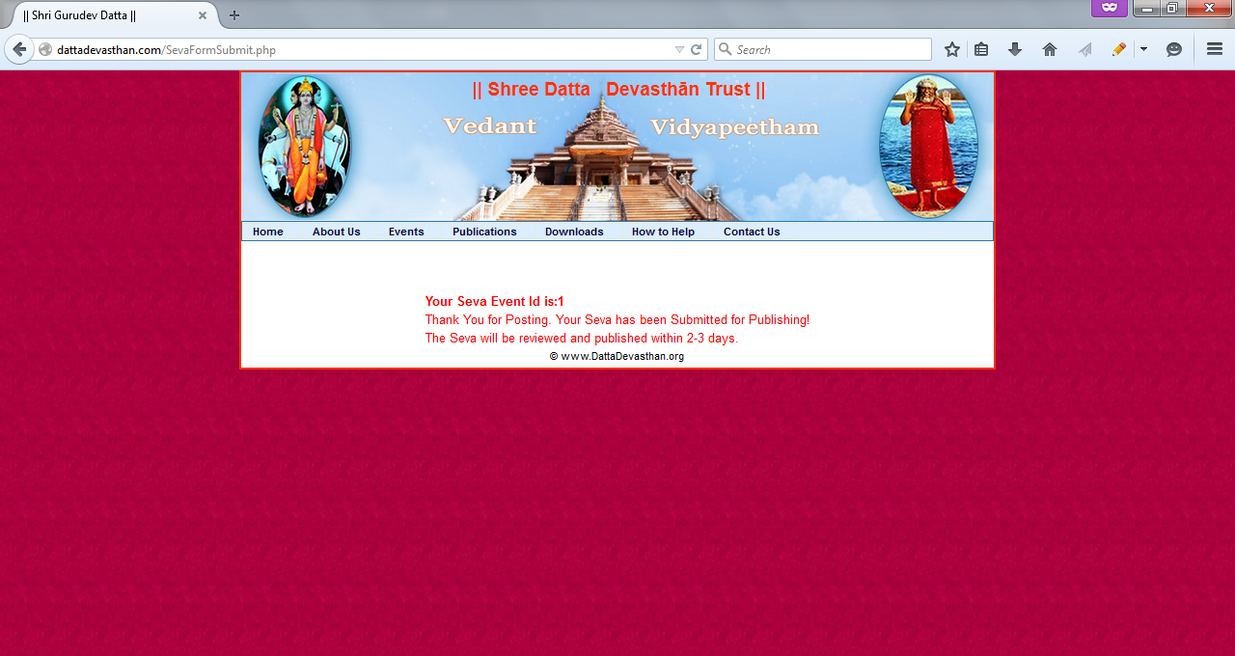

Within 2-3 days seva can be seen at the below link
